# TINTRODUCTION

**Rationale and System Necessity**

In today's fast-paced world, the rising demand for travel, business trips, and leisure has led to a growing need for quick and convenient hotel booking solutions. Instead of visiting hotels in person or making traditional phone inquiries, modern users prefer online platforms to browse room details, compare prices, and secure bookings in advance.

A dedicated hotel booking system not only saves users time but also provides easy access to information, allowing them to take full control of finding the perfect stay. For hotel owners, this system streamlines room management, minimizes operational errors, and elevates service quality. Therefore, a Hotel Room Booking System has become an essential tool for both customers and hospitality businesses.

**What Sets This Project Apart**

Unlike many overly complex booking platforms, this system focuses on core functionalities that are intuitive and accessible to everyone. The system clearly defines roles for Guests, Users, and Managers, ensuring a streamlined experience tailored to each individual's needs. With a clean and visual interface, it provides all the necessary information without overwhelming the user, making the booking process smoother than ever.

# FUNCTIONAL REQUIREMENTS

1. View and Search Rooms

- The system allows users and guests to access and view the list of available rooms without logging in.

- Users can view detailed information of each room, including room type, price, maximum number of guests, amenities, and room status.

- Guests and Users can search for rooms by entering search criteria such as:

+ Room price

+ Number of people

+ Room amenities

- After the user clicks the search button, the system retrieves matching room data from the database and displays the results to the user.

2. User Registration and Login

- A Guest can register a new account by providing full name, phone number, and password.

- The system validates the registration information and returns a success or failure result.

- After successful registration, the user can log in using the registered phone number and password.

- Once logged in successfully, the Guest becomes a User and gains access to user functionalities.

3. Room Booking

- After logging in, a User can select a room from the room list or room detail page.

- The system displays a booking form requiring the following information:

+ Full name

+ Phone number

+ Check-in date

+ Check-out date

+ Email (optional)

- After the User confirms the booking, the system records the booking information and proceeds to the payment process.

4. Payment Processing

- After a successful booking, the system redirects the User to the payment page.

- The system displays payment details, including:

+ User information

+ Check-in and check-out dates

+ Room price, taxes, and fees

+ Total payment amount

- The User can select one of the following payment methods:

+ Bank payment

+ Cash payment

- For bank payment, the system connects to the bank payment gateway to verify the transaction.

- After receiving the payment result, the system updates the payment status of the booking.

5. Cancel Booking

- A User can view the list of rooms that have been booked.

- The system allows the User to request booking cancellation.

- When requesting cancellation, the User is required to provide a reason for cancellation.

- The cancellation request is sent to the Manager for approval.

- The User must wait for the Manager’s decision.

- If the Manager approves the request, the system cancels the booking and updates the booking and room status in the database.

- If the Manager rejects the request, the booking remains unchanged.

6. Room Management (Manager)

- The Manager can manage room information in the system, including:

+ Adding new rooms

+ Deleting rooms

+ Updating room information

- The Manager can change the room status as follows:

+ Available

+ Unavailable

- After confirmation, the system saves the updated room information to the database.

7. User Management (Manager)

- The Manager can view the list of users in the system.

- The Manager can update or delete user information.

- The system validates the updated data before saving changes.

8. Booking Approval (Manager)

- The Manager can view the list of booking requests.

- The Manager reviews booking details and approves bookings.

- After approval, the booking status is updated and the User can log in again to continue using the system.

# Non-Function

**Performance:**

* The system responds to requests within 3 seconds; the system must load quickly.
* Allows access for a large number of users (target: under 15,000 visits).

**Reliability:**

* The error rate should be as low as possible.
* When updating a new version, it must not be deployed directly over the completed production version.

**Security:**

* User information must be protected during storage.

**Availability:**

* The system operates 24/7.
* If a failure occurs, downtime must not exceed the allowable time.

**Privacy Provisions:**

* Comply with government regulations.

**UI:**

* Attractive and easy to use.

**Usability:**

* Provide a user guide for using the system.

**Feasibility:**

* Achievable based on a team of 5 people, with effective task allocation for system implementation and meeting customer requirements.

**Prototype:**

* Use hardware with sufficient storage capacity, powerful processors, and long-term stable operation.
* Use MySQL for data storage.
* Programming language: Java.

# Data Flow Diagram

## Level 0

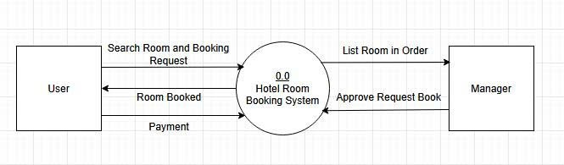

## Level 1

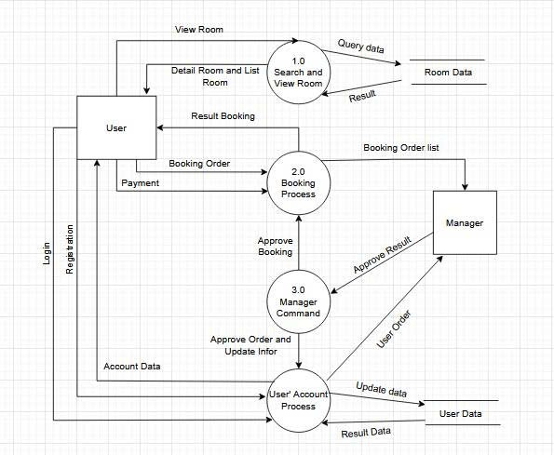

## Level 2

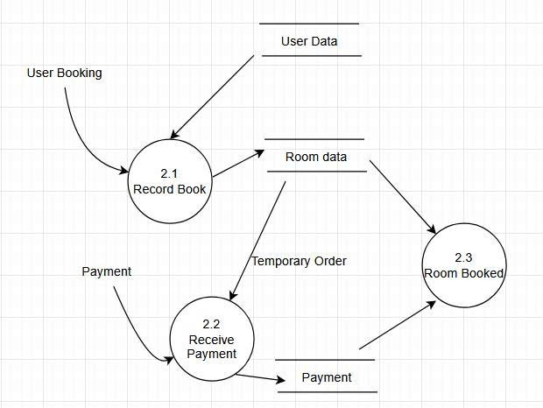

# Use case Diagram

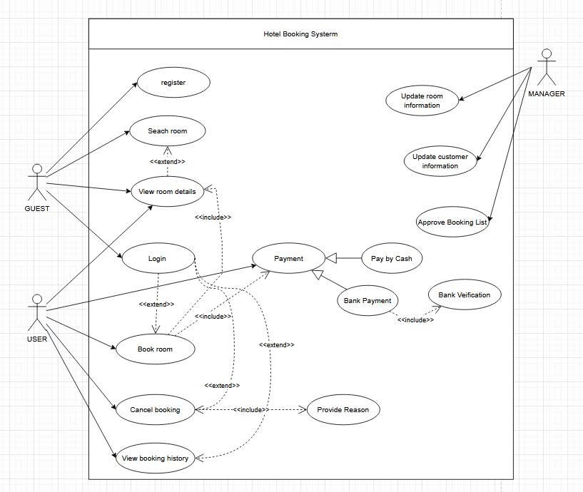

|  |  |
| --- | --- |
| Name use case | Register |
| Actor | Guest |
| Pre-Condition | None |
| Post-Condition | Register Successful |
| Main chain of events:  1.      Enter FullName, Phone Number and Password. After done Click on Register  2.      Information is tranfered to the System, at here will check:  ·         Characters include: Alphabet and Digits  3.      After click, under 2 seconds return result success or fail. | |
| Exception  -          Entering an incorrect phone number or password will result in a login error.  -          Entering invalid characters such as special characters or emojis. | |

|  |  |
| --- | --- |
| Name use case | Login |
| Actor | Guest |
| Pre-Condition | Registered an account |
| Post-Condition | Sign In Successful |
| Main chain of events:  1.      Enter the phone number as the username and enter the password. After completing the input, click the button Sign in.  2.      That information is sent to the system, which checks whether it matches the data in the database and returns the result within less than 2 seconds after the button is pressed. | |
| Exception  -          Entering an incorrect phone number or password will result in a login error.  -          Entering invalid characters such as special characters or emojis. | |

|  |  |
| --- | --- |
| Name use case | View room details |
| Actor | Guest, User |
| Pre-Condition | Access into software |
| Post-Condition | Show room infomation |
| Main chain of events:  1.      From the main menu of the system, users are prompted to choose whether to view as Browse as Guest or Sign in. After the selection, the system assigns permissions accordingly: guests are only allowed to view and search, while users will be redirected to the login process.  2.      Guest/User select the room they want, it’ll send a request to the system. The system queries the database to retrieve the relevant information and returns those details to Guest/User. | |
| Exception  None | |

|  |  |
| --- | --- |
| Name use case | Search Room |
| Actor | Guest, User |
| Pre-Condition | Access into System Provides the requirement (Show list room depends on key word people gives) |
| Post-Condition | Room Found |
| Main chain of events:  1.      The user accesses the search bar, which includes three criteria: price, number of people, and amenities. The results are displayed after the user finishes selecting the criteria and clicks the Search button.  2.      When this happens, the request is sent to the system. The system then accesses the database, searches for matching information, and returns the results to the system, which are finally delivered to the user. | |
| Exception  None | |

|  |  |
| --- | --- |
| Name use case | Book Room |
| Actor | User |
| Pre-Condition | Show detail Room selected (Detail).  Guest Sign in successfully into System. |
| Post-Condition | Room registration successful |
| Main chain of events:  1.      The user views the information of the room they want to book, then clicks on the Booking option on the selected room’s detail page.  -> The system returns the booking registration form  2.      The customer fills in the fields in the form, including Full Name, Phone Number (require), date Check-in (require), date checkOut (require), and Email (option), then Confirm the booking.  -> Show “Successfully Booking” on 5 seconds and moving to Payment | |
| Exception  -          User doesn’t provides Phone Number  -          Phone Number entered with fewer or more than 10 digits.  -          User doesn’t provide date Check-in and CheckOut | |

|  |  |
| --- | --- |
| Name use case | Payment |
| Actor | User |
| Pre-Condition | Booking approved successfully. |
| Post-Condition | Payment successful |
| Main chain of events:  1.      The registration page redirects to the Payment Details section.  ->The payment form is displayed, including: Full Name, Check-in Date, Check-out Date, Phone Number, Room Price, Taxes and Fees, and Total Amount.  2.      The customer fills in the required information in the payment form by selecting a Payment method  ·         Bank Payment: Cardholder Name, Credit Card Number, Expiration Date, CVC security code.  ·         Cash payment.  3.  The system verifies the selected payment method  ·         Bank Payment:  The system connects to the corresponding bank, requests the user to enter the OTP, and the transaction is completed successfully | |
| Exception  -          If a valid account number is not displayed, the User can choose to re-enter it, Select another payment method, or Cancel the order. | |

|  |  |
| --- | --- |
| Name use case | Cancle Booking |
| Actor | User |
| Pre-Condition | Sign in Successful  Show all Room Booked. |
| Post-Condition | Booked Room Removed |
| Main chain of events:  1.      User information provided into System to query the database, return their Rooms have booked  2.      Each Booked in list has a button Cancle Room if the User Click on it, there will appear a table will ask again Cancle or Next to make sure do they clicked by mistake | |
| Exception  None | |

**Update Room**

|  |  |
| --- | --- |
| Name use case | Update Room Information |
| Actor | Manager |
| Pre-Condition | Manager is logged into the system |
| Post-Condition | Room changed Successfully |
| Main chain of events:   1. Manager  can do three things with room: Insert Room, Delete Room, Update Room 2. The Manager selects a room. 3. The Manager changes the room status (Available/Occupied/Maintenance). 4. The Manager confirms the change. 5. The system updates the room status in the database. | |
| Exception  Invalid status value → The system displays an error message | |

**Update User Information**

|  |  |
| --- | --- |
| Name use case | Update Customer Information |
| Actor | Manager |
| Pre-Condition | Manager is logged into the system |
| Post-Condition | User information is updated |
| Main chain of events:   1. Manager can do 2 things: Delete user và Update user 2. The Manager selects a customer from the customer list. 3. The Manager edits customer information. 4. The Manager submits the changes. 5. The system validates the updated data. 6. The system saves the updated information. | |
| Exception  Invalid customer information → The system displays an error message | |

**Approve Booking List**

|  |  |
| --- | --- |
| Name use case | Approve Booking List |
| Actor | Manager |
| Pre-Condition | Manager is logged into the system |
| Post-Condition | New user is updated |
| Main chain of events:   1. Manager open list Booking 2. On the screen and Manager can read profile and click at The button Approve. 3. System receive it and move into User database. 4. The guest come back to page Sign in and do Sign in again. | |
| Exception  None | |

# Class Diagram

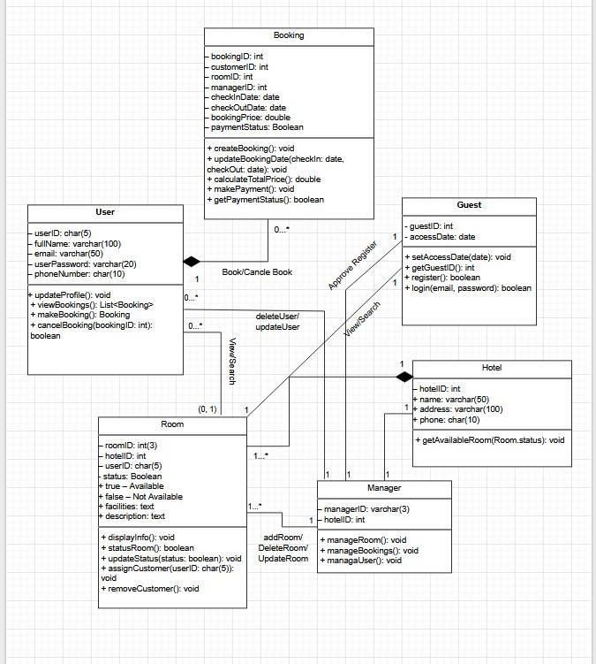

# Data Model

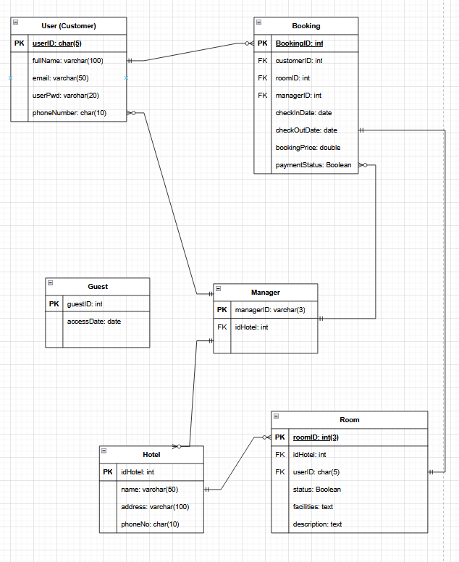

# Interface Design Description

Giao diện sẽ được xây dựng như sau:

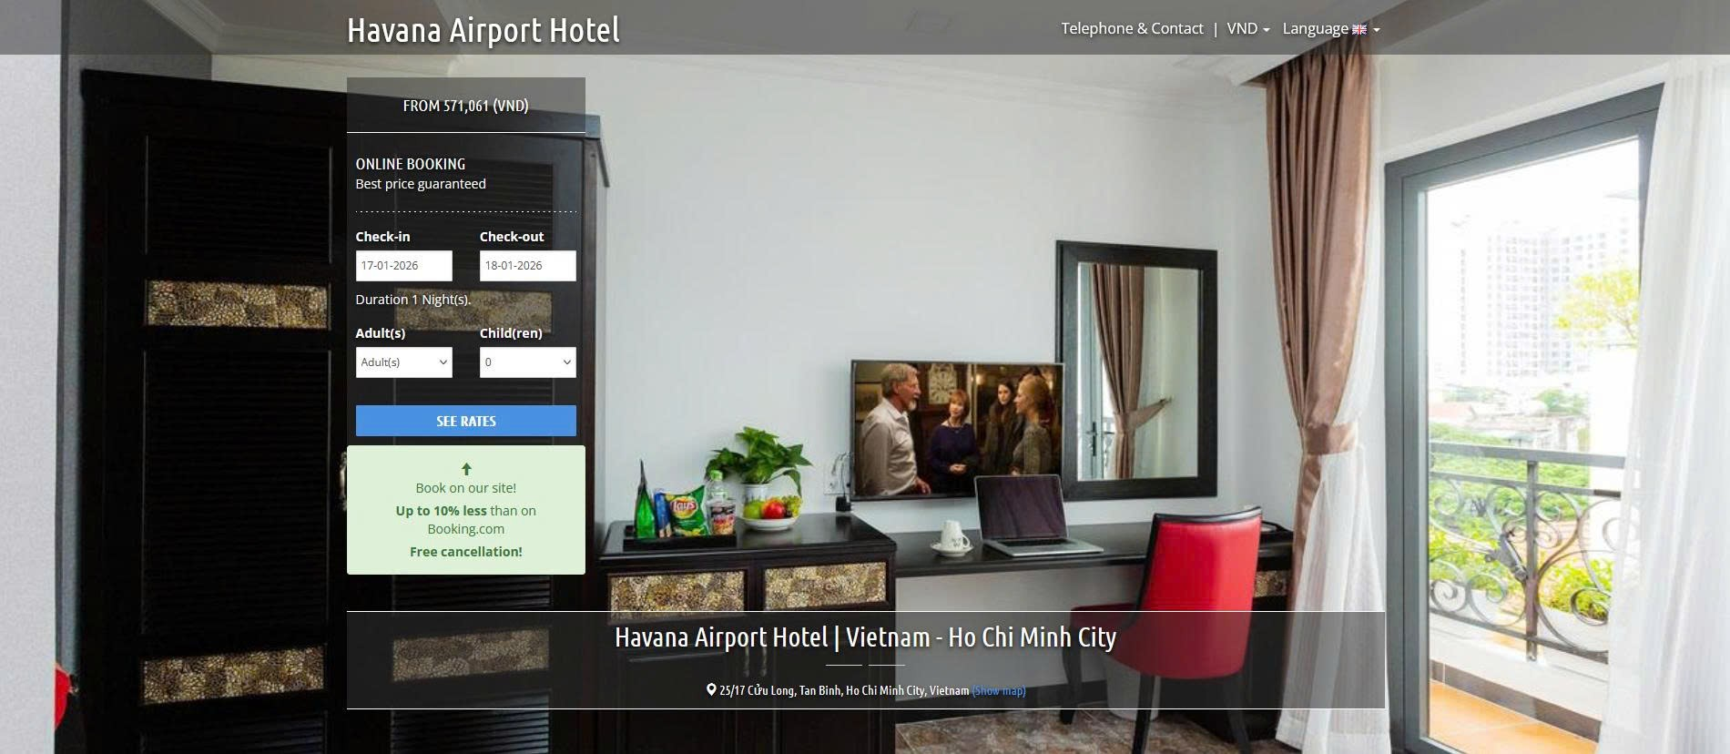

Trong đó thanh tìm kiếm như sau

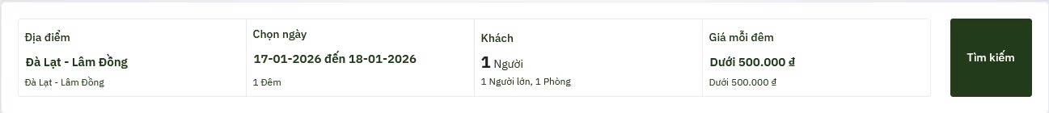

Kết quả tìm kiếm được

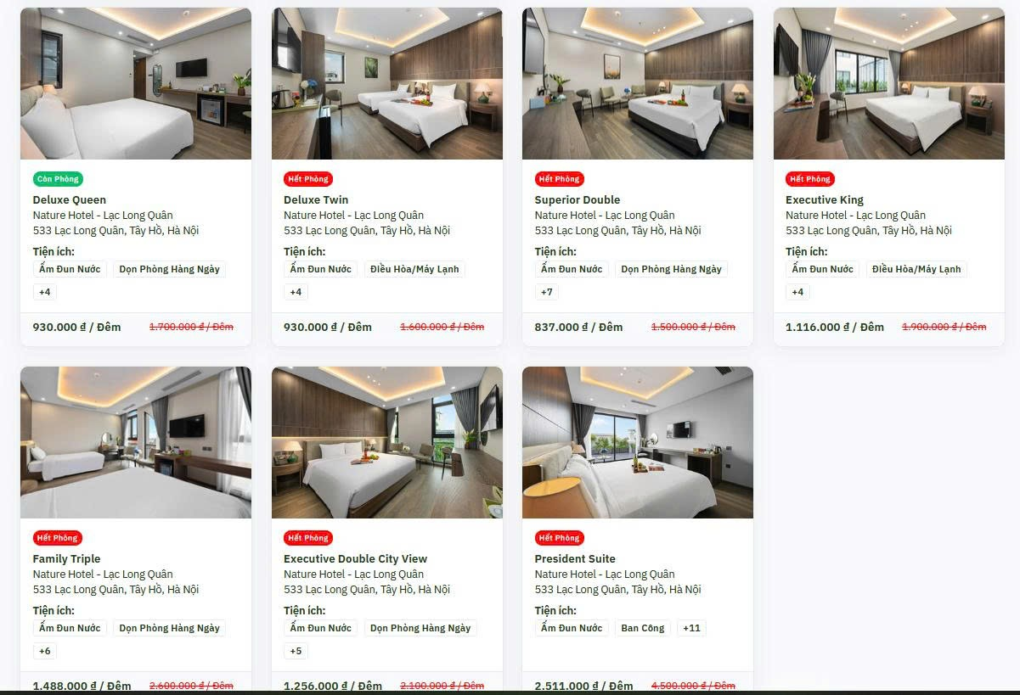

Trang đăng kí

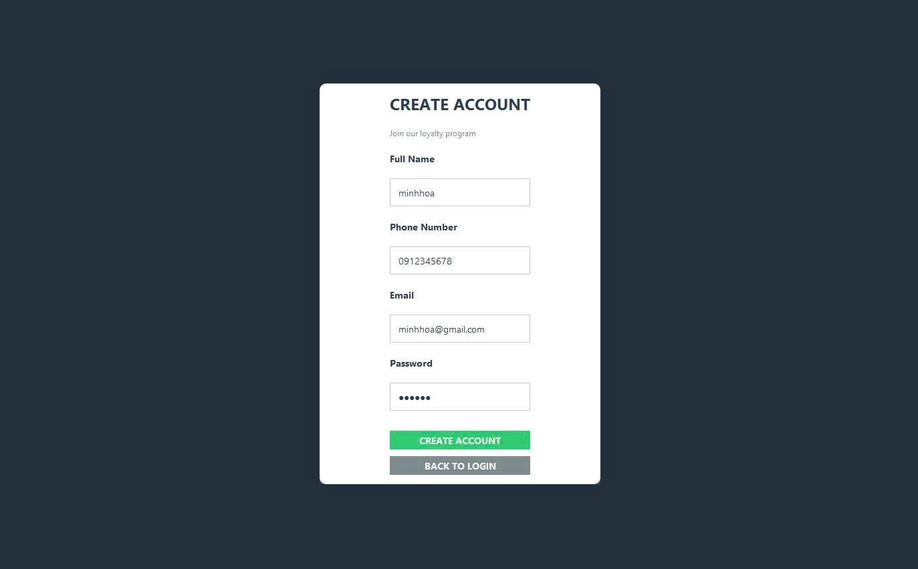

Trang đăng nhập

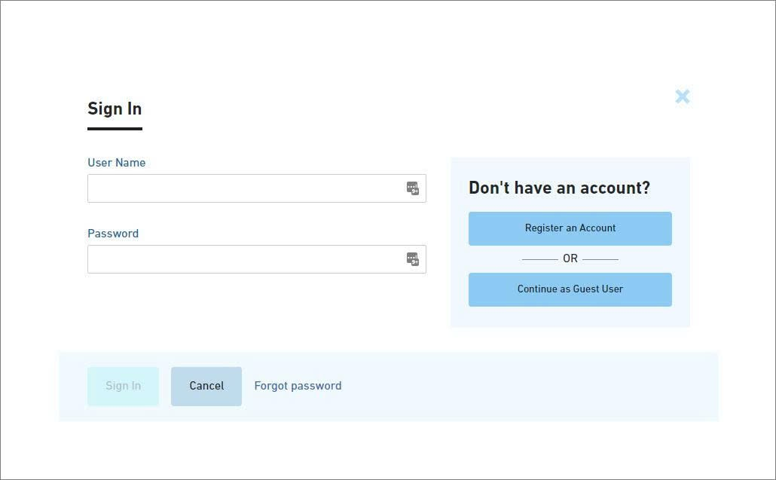

Khi cần đặt phòng sẽ vào trang thông tin sau

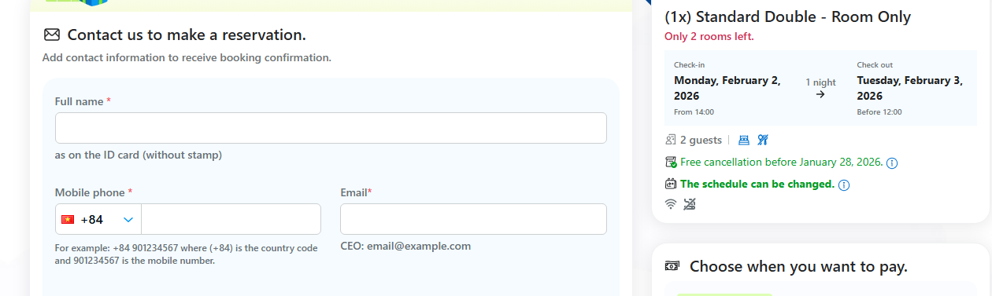

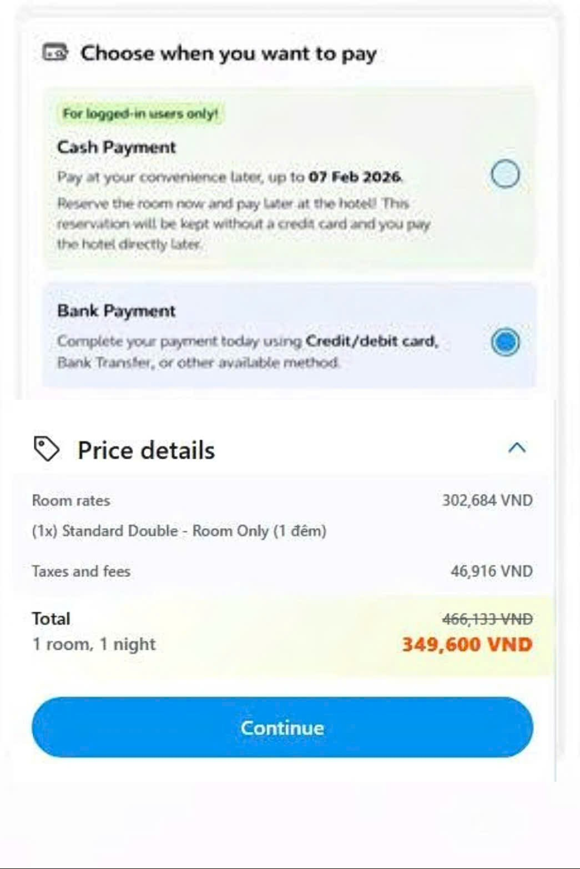

Thông tin cho Payment

–

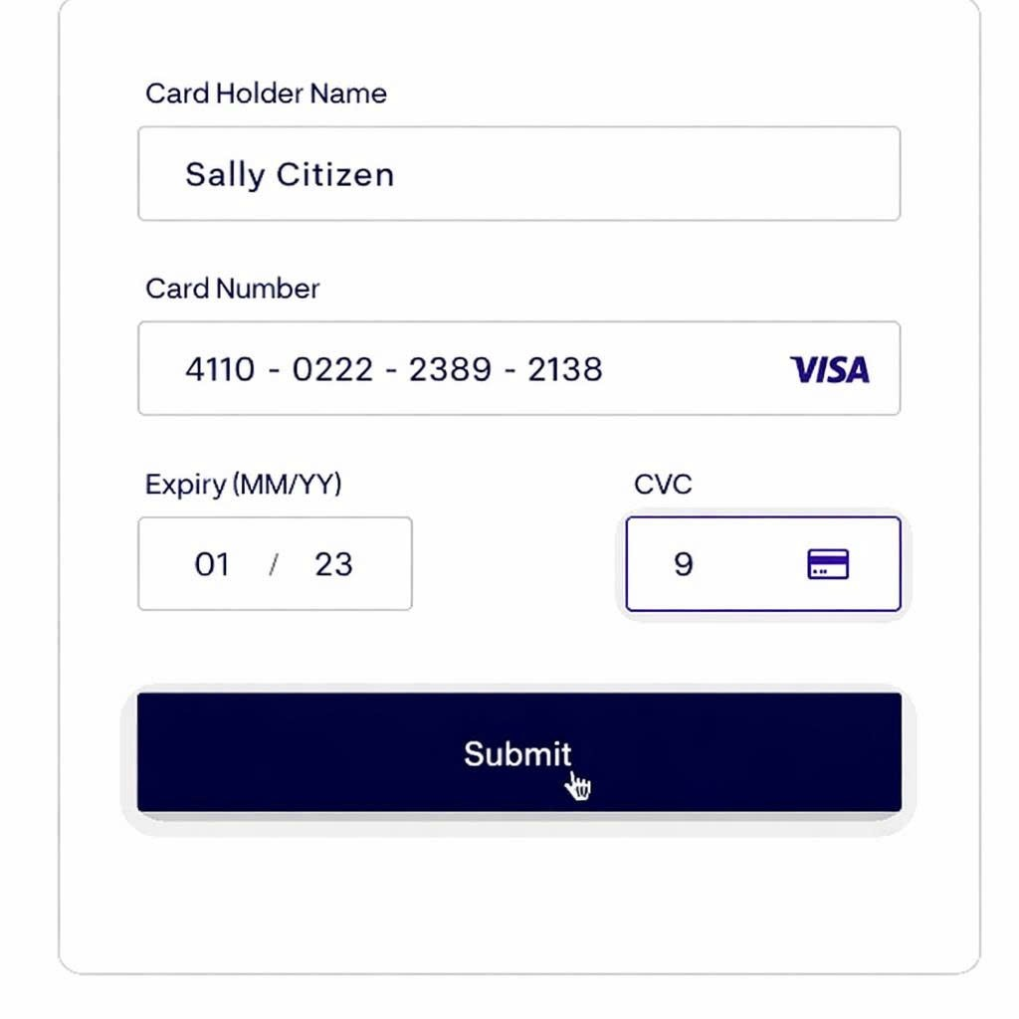

Kết quả payment sẽ được thành công hay lỗi như sau

